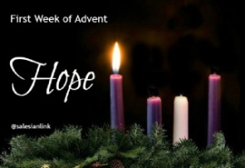
Newsletter 25th November 2022
Advent As part of our RE topic Birthdays’, we have begun to think about the birth of baby Jesus. We have been discussing the true meaning of Christmas and that it is not just about getting new toys and clothes. This Sunday, is the first Sunday of Advent. The children have listened to the Nativity story and they are very excited to be acting it out on Tuesday 13th December 2022 in the hall, parents may arrive from 9.30am. Assembly begins at 10.00am
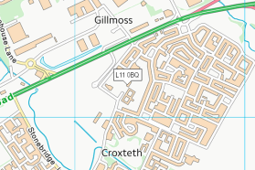
Map Work – Our Local Area The children thoroughly zooming into school from space this week, we used Google Earth to look at our beautiful planet from space. The children were fascinated to identify local features they are familiar with on the map. Why not try it at home? The children drew their very own map of what they see on their journey from home to school. A big thank you to the children who completed the map work on Seesaw!
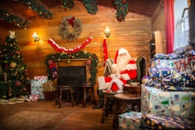
Santa’s Grotto & Workshop Next week, we will be setting up our Grotto and workshop. If you have any spare “Christmassy bits” at home, such as wrapping pap cards, tinsel etc, we would be grateful.
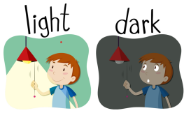
Light & Dark We will be learning about Light and dark over the next few weeks, do you have a torch, headlamp, fairy lights, lava lamp etc that the children could share with the class? We will be investigating shadows, sources of light and rainbows, plus much more! We promise to look after them.
Farmer Teds visit to Santa Monday 5th December 2022 Thank you for your full payments for Farmer Teds. The remaining balance was £12.50, if you paid a £10.00 deposit.
Reading & Homework A big thank you for listening to your child read at home, it really does make a big difference. Please help your child to complete their reading/writing homework booklets too.
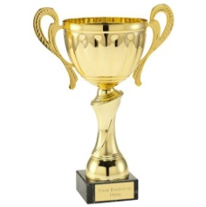
Class Trophy Award This week the trophy is awarded to , for making outstanding progress with her sounds this week and for being a kind and caring friend. Well done !
Thank you for keeping up to date with your snack money. Have a wonderful weekend Mrs Blair, Miss Lee, Miss Doyle & Miss Higgs

