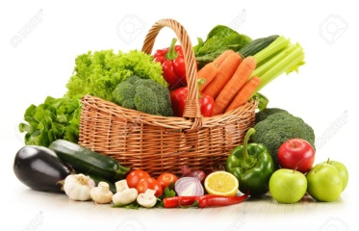
Newsletter 5th November 2021
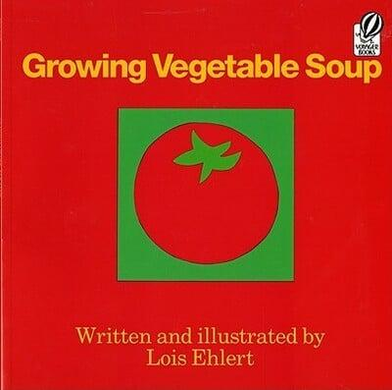
Vegetable Soup Continuing on with our topic about keeping healthy the children really enjoyed reading Growing Vegetable Soup. Thank you so much for the vast selection of vegetables sent into school, and as a result of your effort, we collected 20 different types of vegetables! The children enjoyed discussing, tasting, touching and smelling the vegetables, as well as chopping, slicing and dicing them for their soup. It was delicious!
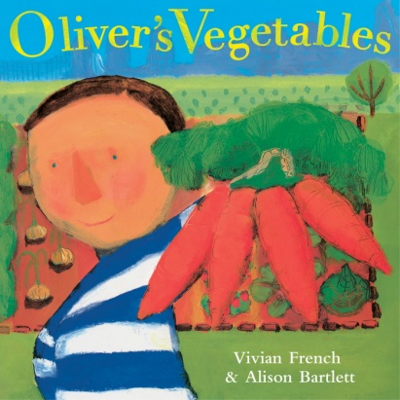
Please go onto the Reception class page of the school website for photographs and into your child’s Seesaw Journal.
Oliver’s Vegetables The children thoroughly enjoyed acting out the story of Oliver’s Vegetables yesterday. They used their very own vegetable patch to search for vegetables, just like Oliver.
I have put links to the stories shared this week on Seesaw and the school website.
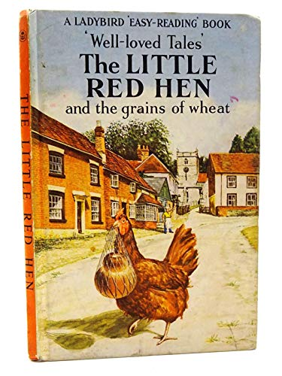
Little Red Hen Today the children learnt off by heart the story of The Little Red Hen, (one of the old fashioned books) they said. They used the props to help them to remember the order of the story, please ask your child to retell it to you. The children had corn bread with their soup today and they will be making their own next week.
School Website www.ourladyandstswithins.co.uk Did you manage to find the Read Write Inc videos on the school website? Children > Class pages > Reception > Read Write Inc or alternatively on your child’s Seesaw Journal
Class Trophy Award The class trophy award this week is awarded to Heidi for super listening, trying her very best and for being a kind friend to others. Well done Heidi!
Judaism Next week the children will be learning about Judaism, in particular the story of Hanukkah
Bonfire Night The children are very excited about Bonfire Night and we hope they have a wonderful time. We have spoken today about staying safe around fires and fireworks.
Have a lovely, safe weekend Mrs Blair, Mrs Hinnigan, Miss Mulligan & Mrs Hayes

