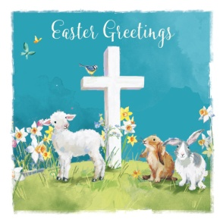
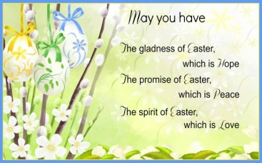
Newsletter 8th April 2022

Thank you so much for attending our Easter sing-a-long and bonnet parade today. I am sure you will agree the children sang beautifully. Thank you very much for making your child their wonderful hats!
Mrs Hamilton was delighted to hear the children sing today.
Reading at Home
The children have worked extremely hard this term and we are really proud of them! Please keep up the great work at home. Please try and read every day, even during the Easter break.
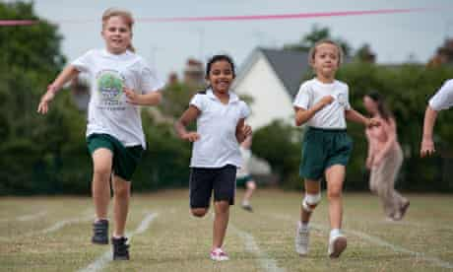
Summer Uniform After the Easter break, you may send your child to school in a green summer dress and school shoes/trainers or grey school shorts and a polo shirt. Children may also wear their school tracksuits if you prefer.
PE Day Our PE day will remain on a Friday for the next half term, please send your child to school in their PE kit/tracksuit and pumps/trainers.
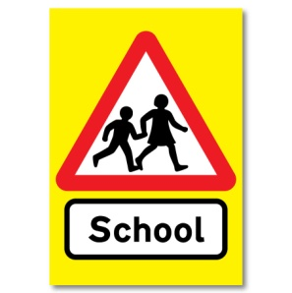
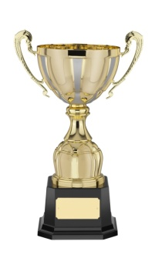
Parking outside School Thank you for your co-operation with parking responsibly, after my letter about parking. Our priority is to keep all children safe.

Class Trophy Award The class trophy is awarded to Luna for always working tremendously hard and for being a really lovely friend to others. Well done Luna!
Thank you for keeping up to date with snack money.
We hope you have a wonderful Easter break
Mrs Blair, Mrs Hinnigan, Miss Mulligan & Mrs Hayes

